**(Optional)Reading: Common Issues in Dash Application**

**Key considerations for developing a Dash application**

1. Please ensure you have added the correct column values as indicated in the hint for each code snippet. Example for **X and Y** in the charts
2. Please ensure that you have used the correct **indentation** in the code.
3. Fill in your code using the **placeholders(….)** provided in the code skeleton provided in the lab. Separate each component by commas.

**Example:** This creates a **Div element in HTML**, a container for other components. Inside this div, various child elements are placed, which need to be separated by commas.

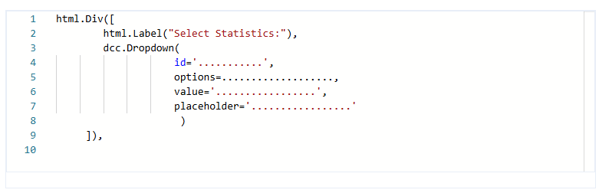

**Common errors:**

**1. Syntax error: invalid syntax def update_input_container(selected_statistics):**

**Solution:** Check if any parentheses or square brackets are unclosed before the **def** function.

The HTML components are organized in a hierarchy using brackets. The use of square brackets **[] within html.Div()** or any other Dash component is essential for defining children elements in a list. This list-based structure allows you to include multiple child components inside a single-parent component.

**Outer HTML**

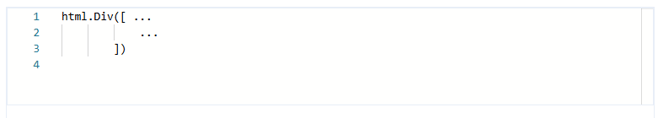

This html.Div is the container for the entire layout of the dashboard. It encapsulates and structures all the other HTML elements as a cohesive unit.

They use square brackets to group multiple child components within a single-parent component. This enables you to structure complex layouts with nested elements.

Dash components need to maintain a clear hierarchy to render correctly. The square brackets help maintain this hierarchy by clearly indicating which components are children of a particular parent component.

**Inner HTML**

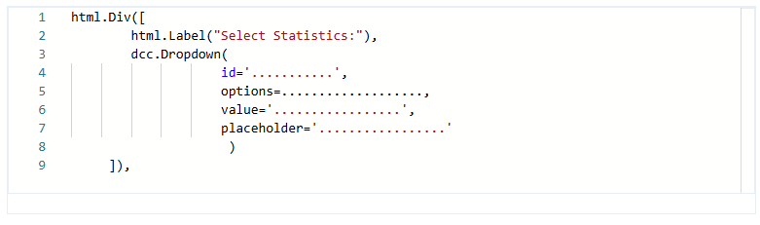

**2. When encountering a Callback error updating output. container.children**

**Solution:** Ensure **Input variables** used within the **callbacks** are defined and correctly scoped in the correct order.

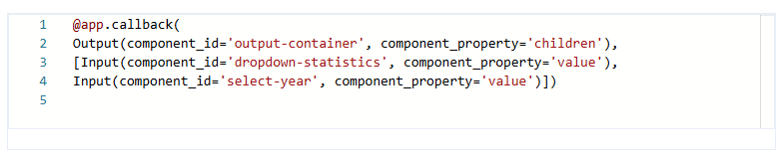

**3. Graph not displaying.**

**Solution:** Ensure you have used the **elif** statement with the correct variable.

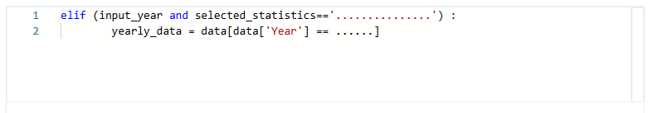

**4. The file could not be located under the project.**

**Solution:** Copy the **wget** command and paste it into the **terminal** to execute. The file will then be in the **Project directory.**

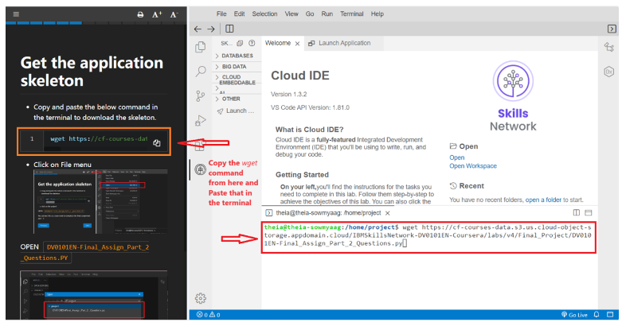

**5. Port 8050 is in use by another program. Either identify and stop that program or start the server with a different port**

**Solution:** Try with different port as shown below:

